SYDNEY SOUTH PLANNING PANEL - ASSESSMENT REPORT
Panel Reference | 2021PPSSSH077
DA Number | RE-503/2018/1
LGA | Canterbury Bankstown Council
Proposed Development | Division 8.2 Review of Determination of the refusal of DA503/2018 for the demolition of existing structures and construction of an 8 storey shop top housing development comprising 4 commercial tenancies and 62 residential apartments, above four levels of basement parking.
Street Address | 41 Broadarrow Road, Narwee
Applicant/Owner | Applicant: Mrs Loulla Costas  Owner/s: Mr Con Costas and Mrs Loulla Costas
Date of DA Lodgement | 19 May 2021  Further information submitted 27 September 2021
Number of Submissions | No (0) Submissions
Recommendation | Refusal
Regional Development Criteria (Schedule 7 of the SEPP (State and Regional Development) 2011 | Part 4, Clause 20(1) of the SEPP (State and Regional Development) 2011 the application is declared as regionally significant development. Schedule 7, 2 includes ‘Development with a capital investment value of more than $30 billion’. The proposal has a capital investment value of $33,062,784.00 and therefore falls within this category.
List of all relevant s4.15(1)(a) matters | - Greater Metropolitan Regional Environmental Plan No. 2 – Georges River Catchment.  - State Environmental Planning Policy 55 – Contaminated Land (SEPP 55)  - State Environmental Planning Policy 65 – Design Quality of Residential Apartment Development (SEPP 65)  - State Environmental Planning Policy 2004 (Building Sustainability Index: BASIX)  - State Environmental Planning Policy (Vegetation in Non-Rural Areas) 2017  - State Environmental Planning Policy (State and Regional Development) 2011  - Canterbury Local Environmental Plan 2012 (CLEP 2012)  - Canterbury Development Control Plan 2012 (CDCP 2012)  - Canterbury Development Contributions Plan 2013 (Contributions Plan 2013)
List all documents submitted with this report for the Panel’s consideration | - Architectural plans  - SEE  - Traffic and Parking Report  - Landscape Plans  - Civil and Stormwater Plans  - Waste Management Plan  - Site Audit Report and Statement  - Detailed Site Investigation  - BASIX Certificate and Plans
Clause 4.6 requests | Clause 4.3- Height of Buildings of CLEP 2012
Summary of key submissions | There were no public submissions.
Report prepared by | Kaitlin McCaffery – Senior Town Planner
Report date | 16 December 2021

Summary of s4.15 matters  Have all recommendations in relation to relevant s4.15 matters been summarised in the Executive Summary of the assessment report? | Yes
Legislative clauses requiring consent authority satisfaction  Have relevant clauses in all applicable environmental planning instruments where the consent authority must be satisfied about a particular matter been listed, and relevant recommendations summarized, in the Executive Summary of the assessment report?  e.g. Clause 7 of SEPP 55 - Remediation of Land, Clause 4.6(4) of the relevant LEP | No- SEPP 55 not met
Clause 4.6 Exceptions to development standards  If a written request for a contravention to a development standard (clause 4.6 of the LEP) has been received, has it been attached to the assessment report? | Yes
Special Infrastructure Contributions  Does the DA require Special Infrastructure Contributions conditions (S7.24)?  Note: Certain DAs in the Western Sydney Growth Areas Special Contributions Area may require specific Special Infrastructure Contributions (SIC) conditions | Not Applicable
Conditions  Have draft conditions been provided to the applicant for comment?  Note: in order to reduce delays in determinations, the Panel prefer that draft conditions, notwithstanding Council’s recommendation, be provided to the applicant to enable any comments to be considered as part of the assessment report | No- recommendation for refusal

EXECUTIVE SUMMARY REPORT

This matter is reported to the Sydney South Planning Panel as the development application is for development that exceeds a capital investment value of $30 million in accordance with Schedule 7 (2) of State Environmental Planning Policy (State and Regional Development) 2011.

The proposed Division 8.2 Development Application Review (DAR)RE-503/2018/1 seeks consent for the following: -
- Remediation of an existing petrol station; and
- Demolition of existing structures and construction of an 8 storey shop top housing development comprising 4 commercial tenancies and 62 residential apartments, above four levels of basement parking. One level of basement car parking including 24 parking spaces, 6 accessible spaces and 16 bicycle spaces; and
- The proposal involves a variation to the building height standard in CLEP 2012. The Applicant has provided a Clause 4.6 Variation Request in this regard.

The DAR has been assessed against the relevant provisions of State Environmental Planning Policy (State and Regional Development) 2011, State Environmental Planning Policy 65, State Environmental Planning Policy No. 55 – Remediation of Land, State Environmental Planning Policy (Building Sustainability Index: BASIX) 2004, State Environmental Planning Policy (Affordable Rental Housing) 2009, Canterbury Local Environmental Plan 2012 and Canterbury Development Control Plan 2012.

The application was neighbour notified and advertised in the newspaper consistent with the provisions contained in the Canterbury Bankstown Community Participation Plan. The application was on exhibition for a period of twenty-eight (28) days from 16 June 2021 to 13 July 2021. No submissions were received during this time.

The key issue that needs to be considered by the Sydney South Planning Panel (Panel) is:
- Insufficient information to adequately meet the requirements of SEPP 55, this is discussed further below in this report.
- The applicant was advised of Council’s final position on the deficient information but has not responded to two of Council’s emails dated 10 and 26 October 2021, respectfully.

POLICY IMPACT

The matter being reported has no direct policy implications.

FINANCIAL IMPACT

The matter being reported has no direct financial implications.

RECOMMENDATION

It is recommended the Sydney South Planning Panel refuse RE-503/2018/1 for aDivision 8.2 Review of Determination of the refusal of DA503/2018 for the demolition of existing structures and construction of 8 storey shop top housing development comprising 4 commercial tenancies and 62 residential apartments, above four levels of basement parking at 41 Broadarrow Road, Narwee, pursuant to Section 4.16(1)(b) of the Environmental Planning and Assessment Act, 1979.

RE-503/2018/1 ASSESSMENT REPORT

PROPOSED DEVELOPMENT
The Applicant seeks development consent for the demolition of existing structures and the construction of a eight (8) storey shop top housing development comprising 4 x commercial tenancies on the ground floor and sixty two (62) residential apartments above and four (4) levels of basement parking. The proposed development is detailed below:

Basement 04
- 2 x lifts and stair wells
- 26 x residential car parking spaces (including 4 x accessible parking spaces).
- Car wash bay
- Storage

Basement 03
- 2 x lifts and stair wells
- 26 x residential car parking spaces (including 3 x accessible parking spaces).
- Car wash bay
- Storage

Basement 02
- 2 x lifts and stair wells
- 25 x car parking spaces (including 1 x accessible parking space and 10 x visitor parking spaces).
- 20 x bicycle spaces
- Sprinkler room
- Storage

Basement 01
- 2 x residential lifts, 1 x commercial lift and stair wells.
- 23 x commercial car parking spaces (including 1 x accessible car parking space)
- 8 x bicycle spaces
- OSD tank, plant room and hydrant pump room
- Residential waste room

Ground Floor
- 2 x residential lifts, 1 x commercial lift and stair wells.
- 4 x business/retail premises including 2 x potential restaurant use.
- 2 x residential lobbies.
- Separate residential and commercial bin holding room.
- Bulky waste storage area.
- 2 x bathrooms.
- Loading zone.
- Vehicular access into basement and commercial loading and unloading via Hurst Place

Level 01
- 2 x residential lifts and stair wells.
- 1 x studio apartment with associated private open space
- 7 x one bedroom apartment with associated private open space
- 5 x two bedroom apartment with associated private open space
- Communal open space

Level 02
- 2 x residential lifts and stair wells.
- 1 x studio apartment with associated private open space
- 6 x one bedroom apartment with associated private open space
- 5 x two bedroom apartment with associated private open space

Level 03
- 2 x residential lifts and stair wells.
- 2 x one bedroom apartment with associated private open space
- 5 x two bedroom apartment with associated private open space
- 1 x three bedroom apartment with associated private open space

Level 04, Level 05 and Level 06
- 2 x residential lifts and stair wells.
- 2 x one bedroom apartment with associated private open space
- 5 x two bedroom apartment with associated private open space
- 1 x three bedroom apartment with associated private open space

Level 07
- 2 x residential lifts and stair wells.
- 1 x one bedroom apartment with associated private open space
- 2 x two bedroom apartment with associated private open space
- 2 x three bedroom apartment with associated private open space
- Communal open space

BACKGROUND
On 21 December 2020 the Sydney South Planning Panel determined to refuse DA-503/2018 which involved the demolition of existing structures and the construction of an eight (8) storey shop top housing development comprising 4 x commercial tenancies on the ground floor and 62 residential apartments above and four (4) levels of basement parking.

The panel determined the application as follows:

Panel Consideration and Decision

The panel considered: the matters listed at item 6, specifically State
Environmental Planning Policy 55 — Contaminated Land (SEPP 55), State
Environmental Planning Policy 65 — Design Quality of Residential Apartment Development (SEPP 65) and-the material listed at item 7 and the material presented at meetings and briefings and the matters listed at item 8 in Schedule 1.

Application to vary a development standard

The Panel considered the written request under Clause 4.6 from the applicant in respect of the breach of height, made under CLEP 2012, Clause 4.3 in relation to height of buildings of the LEP.

The application has demonstrated that:
- compliance with the standard is unreasonable or unnecessary in the circumstances; and

- there are sufficient environmental planning grounds to justify contravening the development standard

The Panel is satisfied that:

a) the Applicant’s written request adequately addresses the matters required to be addressed under CLEP 2012, Clause 4.3 in relation to height of buildings of the LEP.

However, while there were minor non-compliances with regards to traffic, waste and parking and SEPP 65, it was considered that these could be addressed through minor design amendments, the major issue was that the application has not adequately demonstrated with sufficient documentation that the requirements of SEPP 55 to confirm that the site contamination can be effectively remediated and the site made suitable for the proposed use.

The panel determined to refuse the development application pursuant to section 4.16 of the Environmental Planning and Assessment Act 1979. The decision was unanimous.

Reasons for the Decision

The panel determined to uphold the clause 4.6 variation to building height but to refuse the application as the panel was not satisfied as required under clause 7 of SEPP 55 that the site could be made suitable to accommodate the proposed use.

On 12 August 2021, Council briefed the SSPP and the following key issues were discussed:
- Council provided an overview of the site and its context adjacent to the rail line and town centre.
- DA is a very similar design to the previous application that had been refused in late 2020.
- Minor changes are shown clouded on the plans and additional information has been supplied in relation to contamination which was the main reason for the Panel’s previous refusal.
- Improvements have been made to address waste storage and traffic access / pedestrian connectivity adjacent to the rail line.
- A referral has been made to Sydney Trains but a response is yet to be received. It was noted that the previous DA had been supported subject to deferred commencement conditions.
- The design proposes minor encroachments into the height plane however these are not considered significant and were supported by the previous Panel.
- Cross ventilation issues due to proximity to the rail line and required acoustic treatments and the reliance on air conditioning. Council are supportive of a balanced approach given the site constraints.
- Landscaping, deep soil planting and the relationship and arrangement of the roof terraces and Council’s requirement for a management plan for these areas were noted.

Panel Comments:
- Despite the additional information in relation to contamination, the Panel are yet to be satisfied that the provisions of SEPP 55 have been adequately addressed. The Applicant should clarify the approach and the requirement for further investigations and the Council’s assessment report needs to clearly step the Panel through the process and compliance with the statutory framework.
- Plans should be provided to show the location of air conditioning units and whether these impact on private open space arrangements
- The assessment report should clarify the splits between units that achieve cross ventilation and those that don’t.
- The assessment report should include comment on the consolidated draft LEP in terms of the principles of the new design excellence clause. – noting that the DA would be subject to savings and transitional arrangements.
- The Panel notes there is an excess of car parking spaces being provided and this should be raised with the applicant in terms of opportunity for redesign of the basement levels.
- All applicable draft EPIs must be listed and considered in the assessment report.

On 2 September 2021, Council sent a request for further information letter which is summaried below:
- SSPP comments outlined above
- Planning
- Environmental Health
- Traffic

On 27 September 2021, the Applicant submitted amended (revision 5) plans.

On 14 October 2021, Council provided a reponse to the amended plans and outlined several outstanding issues, giving 14 days to respond.

On 26 October 2021, Council sent a follow up correspndance reminding the applicant the deadline to submit amended information prior to the SSPP determination meeting was 28 October 2021.

SITE & LOCALITY DESCRIPTION

The subject site is known as 41 Broadarrow Road, Narwee and is legally identified as Lot 10 in DP 875415. The site irregular in shape and is located on the northern side of Broadarrow Road, on the eastern side of the intersection with Hurst Place.

The site has a primary frontage to Broadarrow Road (southern boundary) of 56.79m, a secondary frontage (western boundary) of 47.48m to Hurst Place, a rear (northern boundary) of 56.25m adjacent to the Narwee Railway Station and a side (eastern boundary) of 12.91m to a small triangular allotment owned by the Electricity Transmission Ministerial Holding Corporation who have a 99-year lease over the land.

The lot is fenced off from the site and the public domain. The site has a total area of 1,696m² and is zoned B2 Local Centre. The site currently comprises a Caltex petrol station with associated structures.

To the south of the site, on the opposite side of Broadarrow Road is B2 zoned land and R3 Medium Density Residential zoned land (see Figure 2 zoning map below), which is located within the Georges River Council Local Government Area. The developments on the northern side of Broadarrow road comprise of a combination of one and two storey retail buildings as well as two and three storey residential flat buildings and a Metro Service station and mechanical repair workshop.

To the west of the site is Hurst Place. On the opposite side of Hurst Place which is zoned B2 Local Centre and comprises of one and two storey commercial and shop top housing developments (see figure 4 below).

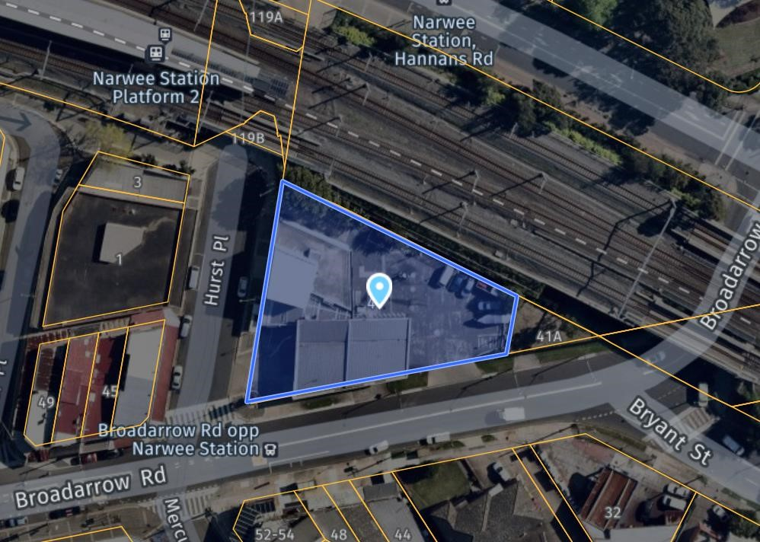
Figure 1: Aerial Map of the subject site outlined in blue (Source: NearMap 2020)

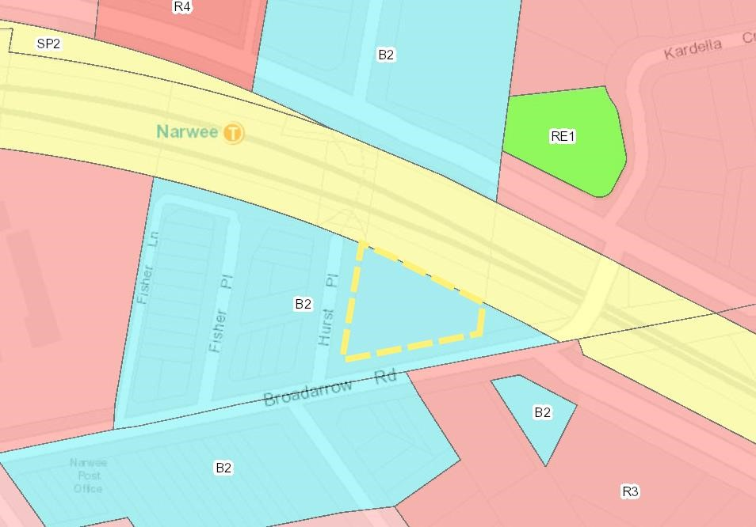
Figure 2: Zoning Map showing site outlined in yellow (Source: NSW Planning Portal 2020)

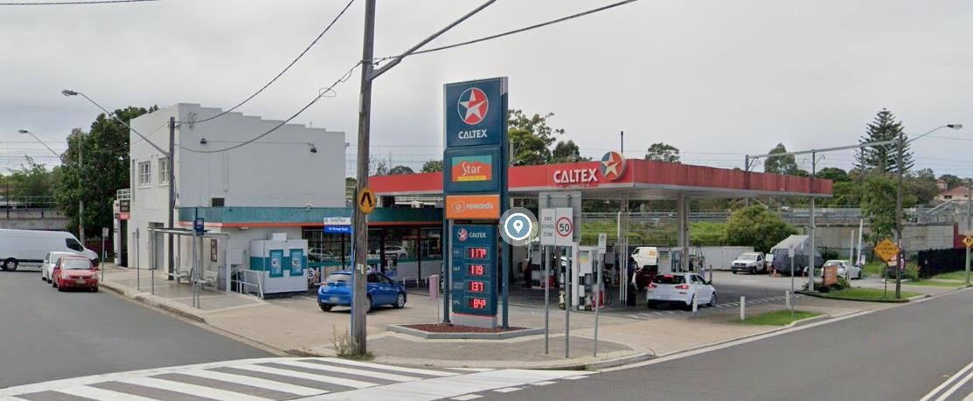
Figure 3: View of the subject site from the intersection of Broadarrow Road and Hurst Place.

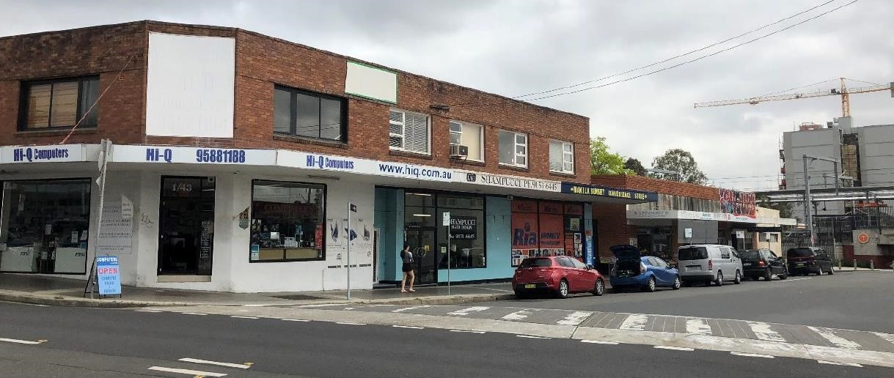
Figure 4: View of the surrounding locality in Hurst place, to the west of the site.

Statutory Considerations
When determining this application, the relevant matters listed in Section 4.15C of the Environmental Planning and Assessment Act 1979 must be considered. In this regard, the following environmental planning instruments, development control plans, codes and policies are relevant:
- Greater Metropolitan Regional Environmental Plan No. 2 – Georges River Catchment.
- State Environmental Planning Policy 55 – Contaminated Land (SEPP 55)
- State Environmental Planning Policy 65 – Design Quality of Residential Apartment Development (SEPP 65)
- State Environmental Planning Policy (Infrastructure) 2007 (SEPP 2007)
- State Environmental Planning Policy 2004 (Building Sustainability Index: BASIX)
- Canterbury Local Environmental Plan 2012 (CLEP 2012)
- Canterbury Development Control Plan 2012 (CDCP 2012)
- Canterbury Development Contributions Plan 2013 (Contributions Plan 2013
- Draft Canterbury Bankstown Consolidated Local Environmental Plan

SECTION 4.15 ASSESSMENT

The proposed development has been assessed pursuant to section 4.15 of the Environmental Planning and Assessment Act, 1979.

State Environmental Planning Policy (State and Regional Development) 2011 According to SEPP (State and Regional Development) a regional panel may exercise the consent authority functions of Council for the determination of applications included in Schedule 4A of the EP&A Act. Schedule 4A includes ‘general development over $30 million’. The proposed capital investment value of $33 million falls within this category. Accordingly, the application is reported to the Sydney South Planning Panel for determination. A Panel Briefing was held on 12 August 2021 The Panel noted several issues at the briefing, which are summarised below:

- Despite the additional information in relation to contamination, the Panel are yet to be satisfied that the provisions of SEPP 55 have been adequately addressed. The Applicant should clarify the approach and the requirement for further investigations and the Council’s assessment report needs to clearly step the Panel through the process and compliance with the statutory framework.
- Plans should be provided to show the location of air conditioning units and whether these impact on private open space arrangements
- The assessment report should clarify the splits between units that achieve cross ventilation and those that don’t.
- The assessment report should include comment on the consolidated draft LEP in terms of the principles of the new design excellence clause. It is noted that the DA would be subject to savings and transitional arrangements.
- The Panel notes there is an excess of car parking spaces being provided and this should be raised with the applicant in terms of opportunity for redesign of the basement levels.
- All applicable draft EPIs must be listed and considered in the assessment report.

Environmental planning instruments [section 4.15(1)(a)(i)]

State Environmental Planning Policy 55 – Remediation of Land (SEPP 55)
Clause 7 of SEPP 55 – Remediation of Land requires Council to consider whether the land is contaminated prior to granting consent to the carrying out of any development on that land. Should the land be contaminated, we must be satisfied that the land is suitable in a contaminated state for the proposed use. If the land requires remediation to be undertaken to make it suitable for the proposed use, we must be satisfied that the land will be remediated before the land is used for that purpose.

Given the existing use on the site is for a service station, it is considered such a use is very likely to have contamination. On this basis, Council must be satisfied that sufficient information has been submitted to demonstrate that remediation works can occur to ensure the site can be made suitable for the proposed commercial and residential use. The review application provides additional supporting information which includes a Site Audit Statement and Remedial Action Plan and the application was referred to Council’s Environmental Health Officer (EHO) who is not satisfied that the Preliminary Site Investigation (PSI) stage 2 report has adequately satisfied SEPP 55 and insufficient information has been submitted.

Please see below an assessment of Clause 7 and response to the outstanding SEPP matters raised by the SSPP panel members and in Councils RFI letter:

Clause 7 - Contamination and remediation to be considered in determining development application
(1) A consent authority must not consent to the carrying out of any development on land unless—
(a) it has considered whether the land is contaminated, and
(b) if the land is contaminated, it is satisfied that the land is suitable in its contaminated state (or will be suitable, after remediation) for the purpose for which the development is proposed to be carried out, and
(c) if the land requires remediation to be made suitable for the purpose for which the development is proposed to be carried out, it is satisfied that the land will be remediated before the land is used for that purpose.
(2) Before determining an application for consent to carry out development that would involve a change of use on any of the land specified in subclause (4), the consent authority must consider a report specifying the findings of a preliminary investigation of the land concerned carried out in accordance with the contaminated land planning guidelines.
(3) The applicant for development consent must carry out the investigation required by subclause (2) and must provide a report on it to the consent authority. The consent authority may require the applicant to carry out, and provide a report on, a detailed investigation (as referred to in the contaminated land planning guidelines) if it considers that the findings of the preliminary investigation warrant such an investigation.
(4) The land concerned is—
(a) land that is within an investigation area,
(b) land on which development for a purpose referred to in Table 1 to the contaminated land planning guidelines is being, or is known to have been, carried out,
(c) to the extent to which it is proposed to carry out development on it for residential, educational, recreational or child care purposes, or for the purposes of a hospital—land—
(i) in relation to which there is no knowledge (or incomplete knowledge) as to whether development for a purpose referred to in Table 1 to the contaminated land planning guidelines has been carried out, and
(ii) on which it would have been lawful to carry out such development during any period in respect of which there is no knowledge (or incomplete knowledge).

The table below shows the response from both the Applicant and Council regarding each of the provisions of Clause 7 of the State Environmental Planning Policy No 55—Remediation of Land.

Provision | Applicant Response | Council Assessment
(1) A consent authority must not consent to the carrying out of any development on land unless—  (a) it has considered whether the land is contaminated, and | The assessments provided confirm the potential presence of contamination due to the use of the site as a service station.  The matter raised by this provision has been answered in the affirmative. | The assessment provided to Council does confirm the potential presence of contamination due to the use of the site as a service station.
(1) A consent authority must not consent to the carrying out of any development on land unless—  (b) if the land is contaminated, it is satisfied that the land is suitable in its contaminated state (or will be suitable, after remediation) for the purpose for which the development is proposed to be carried out, and | The PSI, RAP, Site Audit Report and Site Audit Statement confirms that the site can be made suitable for the development if remediated.  The matter raised by this provision has been answered in the affirmative. | The PSI, RAP, Site Audit Report and Site Audit Statement confirm that the site can be made suitable if further investigations are carried out.  Being that the current investigations undertaken have several significant data gaps and have not been carried out in compliance with relevant EPA guidelines, Council request a DSI be developed to further investigate the site, close significant data gaps, and comply with the EPA guidelines.
(1) A consent authority must not consent to the carrying out of any development on land unless—  (c) if the land requires remediation to be made suitable for the purpose for which the development is proposed to be carried out, it is satisfied that the land will be remediated before the land is used for that purpose. | The land does require remediation to be made suitable for the shop top housing development. The requirements of the Site Audit Statement set out the means for this remediation to be undertaken and include the requirement for a Section A Site Audit following validation of the remediation of the site.  Satisfaction of the requirements of the Site Audit Statement would be required before the use of the site for shop top housing as proposed.  The matter raised by this provision has been answered in the affirmative. | The RAP provided to set out the actions taken to remediate the land are potentially unfeasible/unacceptable as it has been developed based on PSI investigations that have significant data gaps.  Sampling of the site was found to not meet minimum requirements as per the EPA Sampling Design Guidelines and EPA Technical note: Investigation of service station sites.  Council does not accept that this provides enough statistical support for assessing remediation of the site. Furthermore, as per directions in the PSI, groundwater has not been adequately investigated as the wells installed on the site may not adequately intercept contaminated groundwater migrating from UST and UPSS.
2) Before determining an application for consent to carry out development that would involve a change of use on any of the land specified in subclause (4), the consent authority must consider a report specifying the findings of a preliminary investigation of the land concerned carried out in accordance with the contaminated land planning guidelines. | The application is supported by a PSI. The PSI concluded that no actual contamination was encountered and that the site can be made suitable for the proposed development. The PSI recommended the initial RAP be updated and should include a plan to undertake additional investigations when access becomes more readily available relative to the existing buildings and structures on site. This approach has been endorsed by an EPA accredited Site Auditor in the submitted Site Audit Report and Site Audit Statement. | The PSI contains several data gaps including but not limited to:  Groundwater: The groundwater monitoring wells on the site may not be installed adequately to intercept contaminated groundwater migrating from UST and UPPS.  Soil sampling was limited and did not meet the EPA recommended design guidelines for sampling.
(3) The applicant for development consent must carry out the investigation required by subclause (2) and must provide a report on it to the consent authority. The consent authority may require the applicant to carry out, and provide a report on, a detailed investigation (as referred to in the contaminated land planning guidelines) if it considers that the findings of the preliminary investigation warrant such an investigation. | The applicant has carried out and provided the PSI required by clause 7(2). While the PSI found no contamination due to the current use of the site as a service station a RAP has been prepared as the proposed development will require the  decommissioning and removal of underground storage tanks (USTs).  Council has sought further information including a DSI. The information Council has sought is however the information that the Site Auditor in the Site Audit Statement has required to be provide prior to the commencement of remediation.  The Accredited Site Auditor has provided certification that they consider the site can be made suitable and imposed appropriate requirements to be satisfied prior to remediation work commencing.  The matter raised by this provision has been answered in the affirmative as a Site Audit Report and Site Audit Statement has been provided confirming the site can be made suitable for the proposed use. | The PSI provided has several data gaps and does not provide sufficient site characterisation and statistical based evidence to develop a RAP. Council request a DSI be developed as per clause 7(3) to close these data gaps and meet the minimum requirement for investigations.
(4) The land concerned is—  (a) land that is within an investigation area, | The land is not within an investigation area. | Agreed- the area is not within an investigation area.
(4) The land concerned is—  (b) land on which development for a purpose referred to in Table 1 to the contaminated land planning guidelines is being, or is known to have been, carried out, | Table 1 includes as an identified land use “service stations”.  Accordingly, the PSI investigations have been undertaken. | Agreed- the current land use is a ‘service station’ in accordance with Table 1.  Investigations undertaken for the PSI detailed several significant data gaps as previously explained. Council requires further investigations be carried out and a DSI developed and reviewed before development consent is granted.
(4) The land concerned is—  (c) to the extent to which it is proposed to carry out development on it for residential, educational, recreational or child care purposes, or for the purposes of a hospital—land—  (i) in relation to which there is no knowledge (or incomplete knowledge) as to whether development for a purpose referred to in Table 1 to the contaminated land planning guidelines has been carried out, and  (ii) on which it would have been lawful to carry out such development during any period in respect of which there is no knowledge (or incomplete knowledge). | There are no knowledge gaps. The site is currently used as a service station and appropriate investigations and remediation actions have been proposed and endorsed by the EPA accredited Site Auditor. | As provided previously in this response, there are several known knowledge gaps and therefore, consent cannot be granted.

State Environmental Planning Policy 65 – Design Quality of Residential Apartment Development
This policy applies to residential apartment development and is required to be considered when assessing this application. Residential apartment development is defined under SEPP 65 as development for the purpose of a residential flat building, shop top housing or mixed-use development with a residential accommodation component. The development must consist of the erection of a new building, the conversion of an existing building or the substantial redevelopment or refurbishment of an existing building. The building must also be at least 3 or more storeys and contain at least 4 or more dwellings. Residential apartment development does not include boarding houses or serviced apartments.

SEPP 65 aims to improve the design quality of residential apartment development across NSW and provides an assessment framework, the Apartment Design Guide (ADG), for assessing ‘good design’. Clause 50(1A) of the Environmental Planning and Assessment Regulation 2000 requires the submission of a design verification statement from a qualified designer (registered architect) at lodgement of the development application that addresses the design quality principles contained in SEPP 65 and demonstrates how the objectives in Parts 3 and 4 of the ADG have been achieved. These principles are discussed as follows:

Principle 1: Context and Neighbourhood Character
The site is consistent with the objectives of the zone as the development consists of a shop top housing development that incorporates ground floor retail/business uses that will provide for a range of uses to meet the day-to-day needs of persons who live, work and visit the area.

The proposed development will result in a building bulk and a development that is an improvement to the current development that exists at the site. The proposal is compatible with the existing and future character of the area and will contribute to the quality and identity of the immediate locality.

Principle 2: Built Form and Scale
The proposed development is generally compliant with the building envelope controls except for the breach to building height for the lift overrun and other minor encroachments. Notwithstanding the breach to building height, the scale of the development is appropriate on merit given it doesn’t result in any other amenity impacts to neighboring properties and it is one of the first developments of this scale in the immediate vicinity to undergo redevelopment.

The building finishes have been designed to present to the street frontage as three parts made up in the following way; the base which is a one storey element for the commercial spaces, the middle two storeys which are built to the front boundary and the top element which is the upper storeys and which are setback 5m from the primary street frontage (see figure 5 below). The base of the building has been designed mostly with transparent glass finishes and brick tiles for the solid parts of the wall finishes. The upper levels including the middle and top elements have been articulated using appropriate setbacks, planter boxes and brick tile finishes to provide vertical and horizontal articulation. The bulk and scale are considered acceptable through the appropriate use of materials and finishes to provide articulation in the building façade.
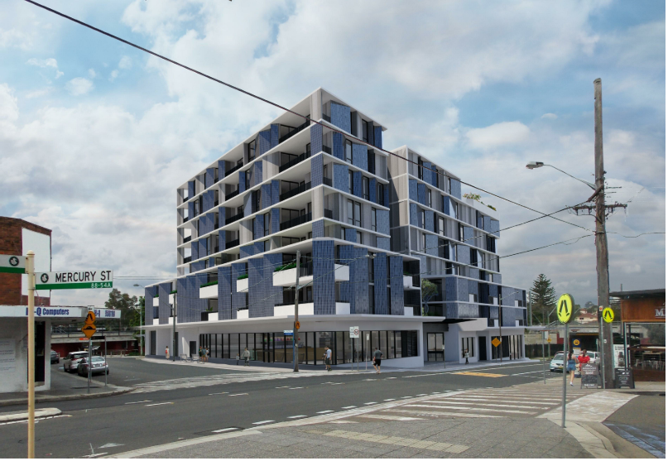
Figure 5. Streetscape view frm Broadarrow Rd Source: Jackson Teece Architects

Principle 3: Density
The proposed density is an appropriate response to the desired future character and built form of the locality particularly given the site’s close proximity to Narwee train station.

Principle 4: Sustainability
A BASIX Certificate has been submitted to Council with this development application, which details the resource, energy and water efficiency measures that will be incorporated into this proposal.

Principle 5: Landscape
The Landscape design principle states that good design is recognised when landscaping and buildings operate as an integrated and sustainable system, resulting in attractive developments that contribute to the landscape character of the streetscape. It also states that good landscape design optimises usability, privacy and opportunities for social interaction, equitable access, and respect for neighbors’ amenity, provides for practical establishment and long term management.

The proposal incorporates landscaping on level 1 and level 7 as part of the communal open space area. There is no deep soil area on ground floor, however given that it is a town centre, this is considered acceptable given that there are no residential apartments on ground floor and complies with the requirements specified within the ADG.

Further, all the proposed apartments have access to private open space, in the form of balconies. The proposal satisfies the relevant landscaping requirements of the ADG and CDCP 2012.

Principle 6: Amenity
Storage is provided within all units with additional storage within the allocated basement car parking levels. The outdoor private balconies are of sufficient size to meet the recreational needs of future occupants. Lift access has been provided from the basement throughout the building, thereby providing full accessibility for all residents and visitors.

Also, except for the layout of two apartments (L01-06 and L02-06) resulting in a snorkel like apartment, the layouts of the remaining 60 apartments meet the layout requirements set out in the ADG. The proposed development also receives more than the minimum requirements of solar access under the ADG, to apartments and POS, resulting from the north orientation of the development.

Overall, the proposed development offers good amenity to individual apartments and for the whole development with the inclusion of two communal open space (COS) areas which include; bench seating, pergola cover and BBQ facilities making the COS usable spaces and to encourage social interaction.

Principle 7: Safety
The safety design principle states that good design optimises safety and security within the development and the public domain. The applicant has considered Crime Prevention Through Environmental Design (CPTED) principles as outlined in CDCP 2012 in the design of the project. The proposal provides increased activation and passive surveillance of the surrounding streets and private open space areas on the site. Residential entry and lobby areas are to be secured and well lit.

Principle 8: Housing Diversity and Social Interaction
This principle aims to achieve good design by providing a mix of apartment sizes, providing housing choice for different demographics, living needs and household budgets. Good design involves practical and flexible features, including different types of communal spaces for a broad range of people and providing opportunities for social interaction among residents.

The proposed design incorporates a mix of studio, one bedroom, two bedroom and three bedroom apartments and includes adaptable units promoting diversity, affordability and access to housing choice.

Principle 9: Aesthetics
The application is accompanied by a Design Verification Statement and confirms that the development satisfies the general design principles contained within SEPP 65.

The articulation of external facades and general compliance with the relevant built form standards reduces the perceived bulk of the building. These elements contribute to the desired future character of the locality and enhance the existing surrounding streetscapes.

Apartment Design Guide
Further to the design quality principles discussed above, the proposal has been considered against the various provisions of the Apartment Design Guide in accordance with Clause 28 (2) (c) of SEPP 65.

Section | Design Criteria | Proposed | Complies
Part 3 Siting the Development
3D Communal and Public Open Space | Communal open space has a minimum area equal to 25% of the site area. | Based on a site area of 1,696m², the communal open space (COS) required is 424m² equivalent to 25% of site area.  193m² COS provided on level 1 and 252m² COS provided on level 7. The total COS provided is 445m² and includes bench seating, BBQ areas and pergola in each COS area. | Yes
3D Communal and Public Open Space | Developments achieve a minimum of 50% direct sunlight to the principal usable part of the communal open space for a minimum of 2 hours between 9 am and 3 pm on 21 June (mid-winter). | At least 50% of the principal usable part of the communal open space receives 2 hours solar access between 9am-3pm on 21 June. | Yes
3E  Deep Soil Zones | Deep soil zones are to meet the following minimum dimensions: | Based on the site area, the required deep soil is 118.72m² with a minimum dimension of 6m.  The proposed development does not provide any provision for deep soil. Notwithstanding the lack of deep soil, the ADG states that; achieving the design criteria may not be possible on some sites including where: the location and building typology have limited or no space for deep soil at ground level (e.g. central business district, constrained sites, high density areas, or in centres) or when there is 100% site coverage or non-residential uses at ground floor level. Where a proposal does not achieve deep soil requirements, acceptable stormwater management should be achieved and alternative forms of planting provided such as on structure. Given the proposal is for a shop top housing development, the 7% deep soil is not required. To place landscaped area along the southern elevation or side boundaries of the development would be uncharacteristic of existing and future development along Broadarrow Road and Hurst Place.  Further, Council’s engineer is satisfied that appropriate stormwater management is met. | Yes
  Site Area | Minimum Dimensions | Deep Soil Zone (% of site area)
  Less than 650m² | - | 7%
  650m² - 1,500m² | 3m | 7%
  Greater than 1,500m² | 6m | 7%
  Greater than 1,500m² with significant existing tree cover | 6m | 7%
3F  Visual Privacy | Separation between windows and balconies is provided to ensure visual privacy is achieved. Minimum required separation distances from buildings to the side and rear boundaries are as follows:  Note: Separation distances between buildings on the same site should combine required building separations depending on the type of room (See Figure 3F.2 of ADG). Gallery access circulation should be treated as habitable space when measuring privacy separation distances between neighbouring properties.  Apartment buildings should have an increased separation distance of 3m (in addition to the requirements set out in design criteria 1) when adjacent to a different zone that permits lower density residential development to provide for a transition in scale and increased landscaping (figure 3F.5) | Rear (northern) Boundary  The rear boundary of the site does not adjoin a residential zone boundary or residential development. The rear boundary adjoins the Narwee Train station and therefore this control is not applicable.  Level 1 to Level 4:  900mm setback to rear boundary, except the blade wall which is right on the boundary on north western corner.  Level 5: 900mm setback to rear boundary  Level 6: 900mm setback to rear boundary  Level 7: 900mm setback to rear boundary  - Side (eastern) boundary  Ground to Level 7 nil setback from the boundary. However,  The Electricity Transmission Ministerial Holding Corporation currently have a 99-year lease over the land which is 120m² and is unlikely to be redeveloped in the future. As noted earlier in this report, the land is zoned B2 and contains grass on the site. There are no impacts on the site and the nil setback is supported.  - Side (western) boundary  Ground floor, level 1 and level 2 storeys nil setback to Hurst Place. Level 3, level 4, level 5, level 6 and level 7 setback 5m from  Hurst Place.  - Front (southern) boundary  Ground floor, level 1 and level 2 storeys nil setback to Broadarrow Road. Level 3, level 4, level 5, level 6 and level 7 setback 5m from Broadarrow Road.  Within the site  The development has been designed to ensure that balconies and windows have appropriate separation distances to comply with the visual provisions of the ADG. | Yes
  Building Height | Habitable Rooms & Balconies | Non-habitable Rooms
  Up to 12m (4 storeys) | 6m | 3m
  Up to 25m (5-8 storeys) | 9m | 4.5m
  Over 25m (9+ storeys) | 12m | 6m
3J  Bicycle and Car Parking | For development within 800 metres of a railway station the minimum car parking requirement for residents and visitors is the lesser of that set out within the Guide to Traffic Generating Developments or Council requirements as set out in the table below. Otherwise, the CDCP controls apply. | Refer to CDCP 2012 assessment. | N/A
3J  Bicycle and Car Parking | The car parking needs for a development must be provided off street. | All parking is provided within the proposed basement. | Yes
Part 4 Designing the Building
4A  Solar and Daylight Access | Living rooms and private open spaces of at least 70% of apartments in a building receive a minimum of 2 hours direct sunlight between 9 am and 3 pm at mid-winter. | 70% of 62 apartments requires solar access which is equivalent to 43.4 (44) apartments.  Majority of the apartments are oriented to the north to maximise solar access to the apartments and POS. The proposal results in 56 of the 62 apartments (90%) receiving at least 2 hours solar access to living rooms and private open space between 9am-3pm on 21 June. | Yes
4A  Solar and Daylight Access | A maximum of 15% of apartments in a building receive no direct sunlight between 9 am and 3 pm at mid-winter | 15% of 62 apartments is the maximum requirement of apartments that should receive no solar access equivalent to 9.3 (10) apartments.  6 of the 62 apartments (9.67%) do not receive any solar access. These apartments are L01-06, L01-12, L01-13, L02-06, L02-12 and L02-13, | Yes
4B  Natural Ventilation | At least 60% of apartments are naturally cross ventilated in the first nine storeys of the building. Apartment at ten storeys or greater are deemed to be cross ventilated only if any enclosure of the balconies at these levels allows adequate natural ventilation and cannot be fully enclosed. | ADG requires that 60% of 62 apartments to be cross ventilated, equivalent to 37.2 (38) apartments.  The proposed development achieves natural cross ventilation for 38/62 apartments, equivalent to 61% of total apartments as demonstrated on DWG 700. However, 24 of the apartments that achieve natural cross ventilation are through windows that face the train line within 20m and are awning windows. As awning windows are limited to opening 125mm as outlined in the BCA (Part D2.24), they will never be able to have adequate air flow to enable cross ventilation. In addition, these windows are close to the train line, and it is unlikely that residents will open them due to the acoustic impacts.  Insufficient information has been provided as to how these windows will achieve adequate natural ventilation whether through an alternative measure or not. | No
4B  Natural Ventilation | Overall depth of a cross-over or cross-through apartment does not exceed 18m, measured glass line to glass line. | All apartments included in the design have a maximum depth of 18m. | Yes
4C  Ceiling Heights | Measured from finished floor level to finished ceiling level, minimum ceiling heights are:  These minimums do not preclude higher ceilings if desired. | Commercial  The floor to ceiling heights for the proposed ground floor tenancies range between 3.7m-4m which meet the minimum floor to ceiling heights specified in the ADG. The variety of heights enable flexibility of commercial/retail and restaurant use within the site.  Residential  The floor to floor height shown on the plans is 3.1m, which includes a slab which is 0.3m between each level. Therefore, the proposed floor to ceiling height provided is 2.7m. | Yes  Yes
  Minimum Ceiling Height for Apartment and Mixed Use Buildings
  Habitable rooms | 2.7m
  If located in mixed used areas | 3.3m for ground and first floor to promote future flexibility of use
4D Apartment Size and Layout | Apartment are required to have the following minimum internal areas:  The minimum internal areas include only one bathroom. Additional bathrooms increase the minimum internal area by 5m² each. | Each apartment complies with the minimum area requirement. However, the studio apartments L01-06 and L02-06 have a minimum floor area of 59m² which is larger than a 1 bedroom apartment.  The layout of these apartments lends themselves to being converted to a 1 bedroom apartment and is not acceptable. | No
  Apartment Type | Minimum Internal Area
  Studio | 35m²
  1 bedroom | 50m²
  2 bedroom | 70m²
  3 bedroom | 90m²
4D Apartment Size and Layout | Every habitable room must have a window in an external wall with a total minimum glass area of not less than 10% of the floor area of the room. Daylight and air may not be borrowed from other rooms. | This requirement can be conditioned. | Yes – via condition of consent should the application be supported
4D Apartment Size and Layout | In open plan layouts (where the living, dining and kitchen are combined) the maximum habitable room depth is 8m from a window. | The apartments with open plan layouts comply with the maximum 8m habitable room depth. | Yes
4D Apartment Size and Layout | Master bedrooms have a minimum area of 10m² and other bedrooms 9m² (excluding wardrobe space).  + | Each master bedroom complies with the minimum 10sqm requirement (excluding wardrobe space). | Yes
4D Apartment Size and Layout | Bedrooms have a minimum dimension of 3m (excluding wardrobe space). | All bedrooms have a minimum dimension of 3m (excluding wardrobe space). | Yes
4D Apartment Size and Layout | Living rooms or combined living/dining rooms have a minimum width of:  - 3.6m for studio and 1 bedroom apartments  - 4m for 2 and 3 bedroom apartments | All living rooms or combined living/dining rooms comply with the minimum width requirements. | Yes
4D Apartment Size and Layout | The width of cross-over or cross-through apartments are at least 4m internally to avoid deep narrow apartment layouts. | The width of cross through is 2.5m for apartments L01-06 and L02-06 resulting in a snorkel like apartment. | No
4E  Private Open Space and Balconies | All apartments are required to have primary balconies as follows:  The minimum balcony depth to be counted as contributing to the balcony area is 1m. | All balconies comply with the minimum area required according to the apartment type and depth requirements. | Yes
  Dwelling type | Minimum Area | Minimum Depth
  Studio apartments | 4m² | -
  1 bedroom apartments | 8m² | 2m
  2 bedroom apartments | 10m² | 2m
  3+ bedroom apartments | 12m² | 2.4m
4F  Common Circulation and Spaces | The maximum number of apartments off a circulation core on a single level is eight. | Max 7 apartments are located off the proposed western core.  Max 6 apartments are located off the proposed eastern core. | Yes
4G  Storage | In addition to storage in kitchens, bathrooms and bedrooms, the following storage is provided:  At least 50% of the required storage is to be located within the apartment. | The storage areas within the basement are not allocated to specific apartments and therefore compliance is unable to be determined.  Notwithstanding this, it is noted that at least 50% of the required storage is located within the apartment and there are 46 storage cages within the basement. Therefore, the remaining storage space required to achieve compliance can be conditioned should the application be supported. | Yes – via condition of consent should the application be supported.
  Dwelling type | Storage size volume
  Studio apartments | 4m³
  1 bedroom apartments | 6m³
  2 bedroom apartments | 8m³
  3+ bedroom apartments | 10m³
4H Acoustic Privacy | Adequate building separation is provided within the development and from neighbouring buildings/adjacent uses.  Noisy areas within buildings including building entries and corridors should be located next to or above each other and quieter areas next to or above quieter areas.  Rooms with similar noise requirements are grouped together.  Noise sources such as garage doors, driveways, service areas, plant rooms, building services, mechanical equipment, active communal open spaces and circulation areas should be located at least 3m away from bedrooms. | The site adjoins Narwee Train Station and East Hills Line to the northern boundary, which requires careful consideration of acoustic privacy to the proposed development resulting from the noise and vibration of the train line.  An Acoustic Assessment Report (Ref 39973, Rev 2, prepared by Wood and Grieve Engineers, dated 12 November 2018) was submitted as part of this application. Council’ Environmental Health Officer reviewed the proposal and Acoutic Report and raised no isses subject to conditions of consent. | Yes

State Environmental Planning Policy (Infrastructure) 2007 (SEPP 2007)
State Environmental Planning Policy (Infrastructure) 2007 aims to facilitate the effective delivery of infrastructure, including providing appropriate consultation with relevant public authorities about certain development during the assessment process.

Clause 85 - 87
The subject site is adjacent to Narwee railway line which requires the concurrence of Sydney Trains given that it has a boundary to the train line. Clause 86(4) of the SEPP states that in deciding whether to provide concurrence, the rail authority must take into account;
(a) the potential effects of the development (whether alone or cumulatively with other development or proposed development) on—
- the safety or structural integrity of existing or proposed rail infrastructure facilities in the rail corridor, and
- the safe and effective operation of existing or proposed rail infrastructure facilities in the rail corridor, and
(b) what measures are proposed, or could reasonably be taken, to avoid or minimise those potential effects.

The original application was referred to Sydney Trains, who granted concurrence to the subject application subject to deferred commencement conditions. The subject review application was referred to Sydney Trains and provided the following response:

Council is advised that Sydney Trains, via Instruments of Delegation, has been delegated to act as the rail authority for the heavy rail corridor and to process the concurrence for this development application.

As such, Sydney Trains now advises that the proposed development is being assessed in accordance with the requirements of Clause 86(4) being:

a) the potential effects of the development (whether alone or cumulatively with other development or proposed development) on:

- the safety or structural integrity of existing or proposed rail infrastructure facilities in the rail corridor, and
- the safe and effective operation of existing or proposed rail infrastructure facilities in the rail corridor, and

b) what measures are proposed, or could reasonably be taken, to avoid or minimise those potential effects.

In this regard, Sydney Trains has taken the above matters into consideration and has decided to grant its concurrence to the development proposed in development application RE-503/2018/1 subject to Council imposing the deferred commencement condition provided in Attachment A and operational conditions listed in Attachment B that will need to be complied with upon satisfaction of the deferred commencement condition.

Should Council choose not to impose the deferred commencement condition in Attachment A and the operational conditions provided in Attachment B (as written), then concurrence from Sydney Trains has not been granted to the proposed development.

The Deferred Commencement Condition reads as follows:

Deferred Commencement Condition

This consent is not to operate until the Applicant satisfies the Council, within 12 months of the date of this consent, that it has obtained approval/certification from Sydney Trains as to the following matters and the approval/certification has been forwarded to the Council:

A1. The Applicant shall prepare and provide to Sydney Trains for review, comment and written endorsement the following final version items in compliance with relevant ASA Standards (https://www.transport.nsw.gov.au/industry/asset-standards-authority):

- Updated Geotechnical Report based on intrusive boreholes, minimum of 2 boreholes on north boundary or sufficient to inform ground model;
- Model ground movement assessment report based on representative borehole data, proposed retention system and excavation and construction sequence;
- Updated Structural report/drawings including Cross sectional drawings showing the rail corridor, sub soil profile, proposed basement excavation and structural design of sub ground support adjacent to the rail corridor. All measurements are to be verified by a Registered Surveyor;
- Confirmation that the movement at the top of the shoring wall under permanent and temporary cases so as to demonstrate the proposed construction will not adversely affect rail operations and rail asset;
- Confirmation that the shoring system design will support the surcharge loading from railway tracks;
- Confirmation that the level difference between community space to the rail track is less than 2 metres. Otherwise, provide evidence of collision protection to the structure in this area to comply with AS5100.2; and
- A ground movement monitoring plan.

Any conditions issued as part of Sydney Trains’ endorsement of the above documents will also form part of the consent conditions that the Applicant is required to comply with.

Based on the above, concurrence has been granted on the basis that a deferred commencement condition is imposed on any approval granted. However, the application is being recommended for the refusal.

Clause 101
In addition to the above, Clause 101 and 102 of the SEPP states that a consent authority must not grant consent to a development that has a frontage to a classified road or a road with an annual average daily traffic volume of more than 20,000 vehicles unless it has considered the following:

- where practicable, vehicular access to the land is provided by a road other than the classified road, and
- the safety, efficiency and ongoing operation of the classified road will not be adversely affected by the development as a result of:
- the design of the vehicular access to the land, or
- the emission of smoke or dust from the development, or
- the nature, volume or frequency of vehicles using the classified road to gain access to the land, and
- the development is of a type that is not sensitive to traffic noise or vehicle emissions, or is appropriately located and designed, or includes measures, to ameliorate potential traffic noise or vehicle emissions within the site of the development arising from the adjacent classified road.

The subject site is located on Broadarrow Road which is a classified road for the purposes of the SEPP. In accordance with Section 138 of the Roads Act 1993, the application was referred to Transport for NSW (TfNSW) formerly known as Roads Maritime Services (RMS) for concurrence given the application comprises the removal of existing vehicular crossings and proposes waste collection from Broadarrow Road.

The subject review application was referred to TfNSW and no objections were raised to the proposed development.

Clause 102
(3) If the development is for the purposes of residential accommodation, the consent authority must not grant consent to the development unless it is satisfied that appropriate measures will be taken to ensure that the following LAeq levels are not exceeded—
- in any bedroom in the residential accommodation—35 dB(A) at any time between 10 pm and 7 am,
- anywhere else in the residential accommodation (other than a garage, kitchen, bathroom or hallway)—40 dB(A) at any time.

An Acoustic Assessment Report (Ref 39973, Rev 2, prepared by Wood and Grieve Engineers, dated 12 November 2018) was submitted as part of this application. The site adjoins the Narwee Train line to the northern boundary. The residential units will meet the relevant acoustic and vibration measures when the windows are closed. Alternative air-flow systems will be provided to the affected units as per the Acoustic Assessment Report.

State Environmental Planning Policy 2004 (Building Sustainability Index: BASIX).
State Environmental Planning Policy 2004 – (Building Sustainability Index: BASIX) A BASIX Certificate accompanies this application. The Certificate makes several energy and resource commitments regarding ventilation, provision of central hot water heating system for each apartment, natural lighting and thermal comfort. These commitments have been shown on the DA plans, when relevant.

In light of the above, the requirements of the BASIX SEPP have been adequately addressed.

Greater Metropolitan Regional Environmental Plan No. 2 – Georges River Catchment
The site is not located within land identified as being affected by Greater Metropolitan Regional Environmental Plan No. 2 – Georges River Catchment, being a deemed SEPP under Clause 120 of Schedule 6 of the EP&A Act, 1979. Therefore, assessment against this SEPP is not required for this development.

State Environmental Planning Policy (Vegetation in Non-Rural Areas) 2017
The proposed development does not seek the removal of any trees. Therefore, assessment against this SEPP is not required for this development.

Housing State Environmental Planning Policy (Housing SEPP)
The Housing SEPP seeks to consolidate a number of existing EPIs addressing affordable housing, seniors housing and introduces new provisions for alternate housing options such as co-living housing. The proposal does not seek consent for any of these housing forms. Accordingly, no further assessment is required.

Canterbury Local Environmental Plan (CLEP) 2012
The following clauses of the Canterbury Local Environmental Plan 2012 were taken into consideration:

This site is zoned B2 Local Centre under CLEP 2012. The objectives of the B2 Zone are as follows:
- To provide a range of retail, business, entertainment and community uses that serve the needs of people who live in, work in and visit the local area.
- To encourage employment opportunities in accessible locations.
- To maximise public transport patronage and encourage walking and cycling.
- To facilitate and support investment, economic growth and development for active, diverse and well-designed centres

The proposal is consistent with the objectives of the zone given the site is located within an accessible area and the ground floor comprises four tenancies which can be used for a range of retail, business, entertainment and community uses that serve the needs of people who work, live or visit the local area.

The CLEP 2012 controls applicable to this application are as follows:

Provision/ Standard | Requirement | Proposal | Complies
Part 2 Permitted or Prohibited Development
2.1-2.8 Zoning | B2 Local Centre | The design comprises a shop top housing development which is a permissible use in the B2 Zone. | Yes
Part 4 Principal Development Standards
4.3 Height of Buildings | 27m | Max 27.6m (lift overrun) | No – refer to comment [1] below
4.4 Floor Space Ratio | N/A | N/A | N/A
Part 5 Miscellaneous Provisions
5.10 Heritage | The consent authority may, before granting consent to any development—  (a) on land on which a heritage item is located, or  (b) on land that is within a heritage conservation area, or  (c) on land that is within the vicinity of land referred to in paragraph (a) or (b), require a heritage management document to be prepared that assesses the extent to which the carrying out of the proposed development would affect the heritage significance of the heritage item or heritage conservation area concerned. | The subject site is not a heritage item or located in an HCA but is located in the vicinity of Narwee Railway Station Group, which is opposite the site. The significance of the site is as follows:  Narwee Railway Station - including the 1931 platform and platform building and pedestrian subway is of local heritage significance. Narwee Railway Station is of historical significance as a major public work completed as an unemployment relief project during the Great Depression, and as a major transport hub for the suburb of Narwee since 1931. That the suburb was named after the railway station is evocative of the historical relationship between the railway station and the development of the suburb. Narwee Railway Station is of aesthetic significance for its austere 1930s platform building with simple Art Deco detailing and fine brick workmanship that is evocative of the effects of the Depression on building programs for large organisations such as the NSW railways. Narwee Railway Station is also distinctive for its 1931 brick pedestrian subway, one of only two such structures on the East Hills line. Narwee Railway Station is representative of the cohesive collection of 10 East Hills line railway stations from Turrella to East Hills.  Whilst the development is close to the station group it would appear the work is located wholly within the boundaries of the site so there is no apparent physical impact on the station building precinct. It would also seem that the development is located east of the main and significant station buildings on site so their presentation and visibility (particularly to Hannans Road which is the main frontage) will remain visible as will the underpass that connects Hannans Road and Hurst Place (the secondary frontage to the development). Whilst a large development, Council’s Heritage Advisor is satisfied there are no adverse heritage impacts on the station precinct as identified in the statement of significance identified above. | Yes
Part 6 Local Provisions
6.1 Acid Sulfate Soils | An Acid Sulfate Soils Management Plan is required for works on Class 5 land within 500 metres of adjacent Class 1, 2, 3 or 4 land that is below 5 metres Australian Height Datum and by which the water table is likely to be lowered below 1 metre Australian Height Datum on adjacent Class 1, 2, 3 or 4 land. | The site is not identified as being affected by acid sulfate soils. | Yes
6.2 Earthworks | Before granting consent to development including earthworks, the following must be considered:  - drainage patterns and soil stability  (b) the likely future use or redevelopment of the land,  (c) quality of the fill or the soil to be excavated, or both,  (d) effect of development on existing and likely amenity of adjoining properties,  (e) the source of any fill material and the destination of any excavated material,  (f) the likelihood of disturbing relics,  (g) the potential for adverse impacts on, any waterway, drinking water catchment or environmentally sensitive area,  (h) appropriate measures proposed to avoid, minimise or mitigate the impacts of the development. | The application was referred to Council’s EHO team to provide a comment on the preliminary site investigation report provided by the applicant to determine if the site can be made suitable from the existing use as a petrol station to the proposed residential and commercial use. Council’s EHO was not satisfied that sufficient testing had been undertaken to conclude if the site can be made suitable in terms of contamination which is discussed in detail under SEPP 55 assessment earlier in this report.  Additionally, the application was referred to Water NSW as the proposed development involves dewatering. Water NSW were satisfied with the proposed development subject to conditions of consent. | No
6.4 Stormwater Management | Consent must not be granted unless:  - Water permeable surfaces are maximized having regard to soil characteristics affecting on-site stormwater infiltration.  - Includes on-site detention if practical as an alternative means of water supply.  (c) Avoids significant impacts of run-off on adjoining land or the environment or minimises and mitigates impacts. | The application was referred to Councils Development Engineer who raised no objection to the design, subject to the inclusion of a deferred commencement condition, should the application be approved. | Yes
6.6 Essential Services | Development consent must not be granted to development unless the consent authority is satisfied that any of the following services that are essential for the development are available or that adequate arrangements have been made to make them available when required—  (a) the supply of water,  (b) the supply of electricity,  (c) the disposal and management of sewage,  (d) stormwater drainage or on-site conservation,  (e) suitable vehicular access. | Council’s Engineer’s raised objection to the proposed design in terms of vehicular access into the commercial vehicular crossing and concern regarding pedestrian sight triangles and therefore clause 6.6(e) is not satisfied.  The sight triangle as marked on the driveway to the commercial / residential loading / unloading area does not comply with Figure 3.4 of AS 2890.2:2018. Council’s Traffic unit is not able to support this lack of sight distance triangles, as the safety of pedestrians at a train station entry is at risk.  A detailed response of these reasons is detailed under the DCP heading B1 Transport and Parking later in this report.  The proposed design makes provision for disposal and management of sewage and supply of water.  In terms of electricity supply, a substation is required and shown on the plans.  Council’s Development Engineer raised no concern regarding the proposed stormwater drainage design. | No

The development t is generally compliant with the provisions of Canterbury LEP
2012 apart from Clause 4.3 - Height. The maximum height permitted on the site is 27m and the proposed development involves a maximum height of 27.6m to the lift overrun. A Clause 4.6 variation is sought by the applicant seeking a variation to the height standard. The assessment below is based on the current design submitted to Council which is consistent with the previous design in terms of height.

Clause 4.6 Variation Request
Pursuant to Clause 4.6 of CLEP 2012, the applicant has made a submission seeking a variation to the provisions contained in Clause 4.3 of CLEP 2012. The Clause 4.6 submission details the extent of the variation as follows:
- 27m – Building Height maximum
- 27.6m – Maximum Building Height proposed.
- 0.6m - 2.22% variation.

The area of the encroachment to the permissible height control is shown in the 3D montage below (source: Jackson Teece Architects).

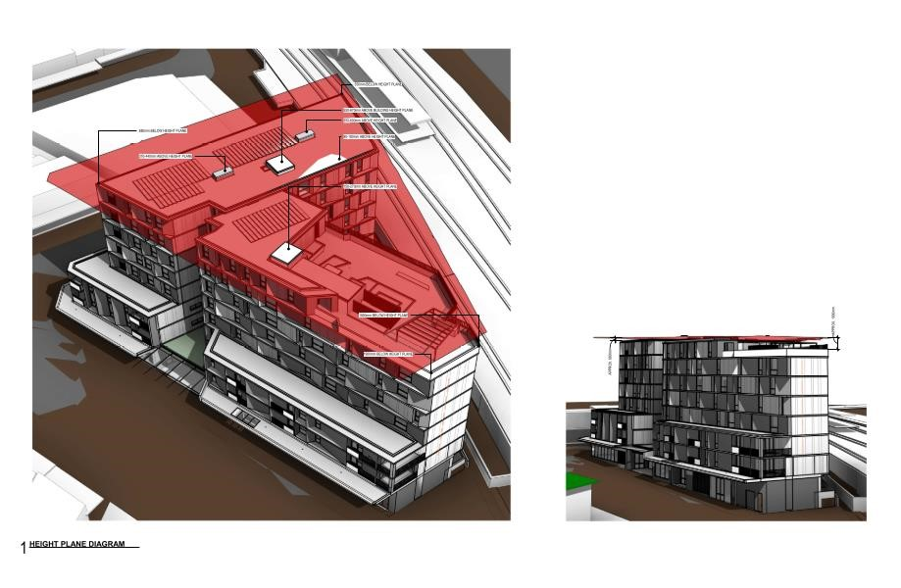
The Applicant’s written request is as per the original application and states that:

“The protrusions above the height of buildings development standard are minor comprising small elements of lift over run, clerestory windows and a small section of the inner roof above the central courtyard area. The substantial elements of the building, including the balustrade of the upper level communal open space are up to 1.9m below the height of Buildings development standard. The actual communal area would be an additional 1m lower. The interface to the public domain is numerically compliant.”

The applicant’s justification under Clause 4.6(3)(a) and (b) of the CLEP 2012 is as follows:

3. Development consent must not be granted for development that contravenes a development standard unless the consent authority has considered a written request from the applicant that seeks to justify the contravention of the development standard by demonstrating:

a) that compliance with the development standard is unreasonable or unnecessary in the circumstances of the case,

- “The application seeks consent for a part eight (8) and part seven (7)
- storey building. This outcome is entirely consistent with the scale that is reasonably anticipated with a 27.0m height of buildings development standard;
- Council’s Development Control Plan (DCP) requires a 3.3m floor to ceiling height for ground floor tenancies. The application proposes ground floor tenancy ceiling heights of up to 4.4m which accords with the best practice guidance of the Apartment Design Guide (ADG) at Part 4C to maximise the flexibility of use of ground floor tenancies to include food premises;
- A numerically compliant height would be achieved if the lessor guideline of the DCP at Part D1.3.3 were complied with compared to the superior outcome proposed which aligns with the ADG;
- The non-compliant elements of the building do not result in any adverse environmental impacts by way of loss of solar access or loss of views; and
- Strict numerical compliance of a reduced ground floor tenancy ceiling height would be compliant with the DCP, an inferior commercial tenancy would be created.”

Comment:
Council generally accepts the reasons provided by the Applicant. It is acknowledged that the proposed variation does not contribute to any additional overshadowing of the proposed properties within the site or on adjoining properties as the shadow cast from the elements that breach the building height, cast onto the roof of the proposed development itself.

The floor to ceiling heights achieved at the ground floor level commercial/retail areas will increase the number of uses which can occupy these premises and will assist in achieving the objectives of the zone.

Upon re-consideration of the matter as part of this application, Council’s opinion remains unchanged and the proposed Clause 4.6 variation adequately addresses that compliance with the development standard is unnecessary or unreasonable in the circumstances of this case.

b) that there are sufficient environmental planning grounds to justify contravening the development standard.

The Applicant’s written request gives the following reasons that there are sufficient ‘environmental planning grounds’ to justify contravening the development standard:

“The proposed non-compliant elements essentially comprise lift overruns and skylights required in order to service the proposed development. These elements are noncompliant through the provision of ground floor commercial tenancy heights consistent with the ADG, but which are greater than the guidelines in the Canterbury DCP. The DCP would allow a ceiling height of 3.3m, compared to the recommended minimum of 4.0m contained in the ADG. That is the heights of the ground level have been maximised to ensure that they are suitable for a broad range of non-residential uses, rather than minimised to achieve numerical compliance.

The maximum non-compliance is 600mm. The recommended minimum ceiling height in the ADG is 700mm greater than the recommended height contained in the DCP. As a consequence, provision of the inferior DCP outcome would result in the building being 100mm below the maximum height of buildings development standard.

The provision of a ground floor ceiling height aligned with the ADG, a superior quality of tenancy is created with greater flexibility in future range of land uses to ensure the greatest potential is given to the establishment of a vibrant Narwee Town Centre.

This superior outcome in conjunction with the lack of an environmental impact supports the minor noncompliance on environmental planning grounds particularly as it cannot be said that the 27.0m building height envelope has not been over reached was evidenced by the provision of communal open space at level 7 which is below the maximum permitted height of buildings development standard.

It is also noted that the proposed solar panels, some of which exceed the maximum permitted height, provide a public benefit by reducing energy consumption associated with the proposed development.

To this end, the non-compliant elements provide for public benefits which contribute to justifying contravention of the building height standard and no undesirable precedent will be set by the minor non-compliance”.

Comment:
Council agrees that having higher floor to ceiling heights for the commercial premises increases the type of uses which can be accommodated in these spaces, specifically restaurants that would facilitate in activating Hurst Place, which provides a pedestrian access entry point into the station.

In addition to the above, the additional height does not result in any additional amenity impacts to neighbouring properties, when compared to a design that complies with the maximum 27m building height standard, given the location of the elements on the roof structure.

As per the initial assessment, Council is satisfied that the proposed breaches to the building height do not result in any solar access or privacy impacts to surrounding properties.

4. Development consent must not be granted for development that contravenes a development standard unless:
a. the consent authority is satisfied that:

- the applicant’s written request has adequately addressed the matters required to be demonstrated by subclause (3), and

Comment: As detailed above, the written request has adequately addressed the matters required in subclause 3 above.

- the proposed development will be in the public interest because it is consistent with the objectives of the particular standard and the objectives for development within the zone in which the development is proposed to be carried out, and

The objectives for building height seek:
- to establish and maintain the desirable attributes and character of an area,
- to minimise overshadowing and ensure there is a desired level of solar access and public open space,
- to support building design that contributes positively to the streetscape and visual amenity of an area,
- to reinforce important road frontages in specific localities.

Comment:
It is considered that the proposal is consistent with the objectives of the development standard for the following reasons:
- The proposed height breach will assist with the development establishing the desirable attributes of the progressing town centre at this location with floor to ceiling heights allowing a wider range of uses at the ground floor commercial/retail units without compromising the amenity of neighbouring developments.
- The part of the development that breaches the 27m maximum building height standard is not visible from the primary road frontages. The proposed development maintains a part 7 and part 8 storey form which is the maximum number of storeys envisaged by the building height development standard. Also, the development has been built to the boundary for the first three storeys and setback 5m from the street frontages for the upper floors, maintaining a base, middle and top in the building design. The proposed number of storeys
- The development is in keeping with the future desired character of the streetscape and locality.
- The proposed building replaces an existing service station which is one of two in this relatively small town centre. The proposed building is of a design that will more actively address both street frontages and positively contribute to the vibrancy of the centre, streetscape and visual amenity of the area.
- As demonstrated in this report, the proposed development achieves the minimum solar access requirements to apartments, private open space and communal open space. It should be noted that the residential flat building opposite the site at 42 Broadarrow Road and experiences overshadowing through the day, which is inevitable given its southern orientation to the subject site. Notwithstanding this, 42 Broadarrow Road is still capable of achieving solar access between 8:00am and 10:00am on 21 June. The units above 52 Broadarrow Road, also opposite the site, are almost completely enclosed around the perimeter, therefore the proposed development will not impact on the solar access to these balcony areas. Also, the breaches to the building height do not result in the development receiving any less solar access as the shadows from the roof top elements fall on the roof top itself.
- The proposed restaurants and commercial premises on ground floor, particularly on the Hurst Place frontage contributes to activating the street frontage. The use of transparent glass also facilitates interaction between the private and public domain.

The objectives for the B2 Local Centre Zone seek:
- To provide a range of retail, business, entertainment and community uses that serve the needs of people who live in, work in and visit the local area.
- To encourage employment opportunities in accessible locations.
- To maximise public transport patronage and encourage walking and cycling.
- To facilitate and support investment, economic growth and development for active, diverse and well-designed centres.

Comment:
As stated previously, the proposed development will replace one of two service stations in this small town centre that is detached into two parts by a railway line and train station. The ground floor tenancies addressing both street frontages successfully activate this section of the town centre and strengthen the connection between the train station and the town centre. This in turn will allow for a range of uses that serve the needs of people who live in, work in and visit the local area.

The activation of this corner will assist with establishing a safer environment with increased natural surveillance for public transport patrons that access the train station and other connecting modes of travel. A robust design at ground level increases the range of uses at this level, which can provide day and night time economies in the town centre and lead to increased employment opportunities in this accessible location.

As shown above and in line with this report, the proposed variation to the building height development standard is consistent with the objectives of the zone and development standard. Accordingly, approval of such variation would be in the public interest.

b. the concurrence of the Secretary has been obtained.

Comment:
The concurrence of the Secretary is assumed having regard to previous advice received from the Department of Planning and Environment in Circular PS 18-003
‘Variations to development standards’, dated 21 February 2018.

Conclusion of Clause 4.6
As outlined above, it is considered there is sufficient environmental planning grounds to justify a contravention to the height of buildings development standard, in this instance for the reasons outlined above.

Draft environmental planning instruments [section 4.15(1)(a)(ii)]

Consideration of Draft EPIs

Draft Canterbury Bankstown Consolidated LEP
Draft Canterbury Bankstown Consolidated LEP 10 / 14 SJB Planning SJB Planning (NSW) Pty Ltd ACN 112 509 501 8422_5_RFI Response_Final_210924

The draft Canterbury Bankstown Consolidated LEP does not propose to alter the land use zone, land use permissibility or Height of Building development standard currently applying to the land. No FSR development standard is proposed to be introduced.
Having regard to the intended land use and built form of this application no relevant changes are proposed that would impact upon the assessment of the application.

Draft Clause 6.14 Design Quality is proposed to apply to stop top housing developments. Clause 6.14 as drafted and if in force would require a consent authority to have regard to a range of design quality indicators.
In considering the draft Clause 6.14 provisions the consent authority could be satisfied that the proposal:
  - Will contribute positively to the Narwee Commercial Centre streetscape, with active retail frontages and street interface consistent with the applicable DCP provisions;
  - Will contribute positively to the public domain providing active interface, retail options and improved pedestrian amenity conditions;
  - Will comprise materials that are durable, high quality and of low maintenance;
  - Is of high architectural quality from a well-regarded architectural firm;
  - Has sought to maximise solar access, ventilation and the extensive use of solar panels contributing to ESD performance;
  - Includes room layouts that are functional and fit for purpose;
  - Integrates landscaping into the design at ground level and within upper levels of the building; and
  - Does not detract from any heritage items in the vicinity.

The draft DCP proposes no changes to the provisions currently applying under the Canterbury DCP, other than car parking. As such no further assessment of the Draft DCP is necessary.

Draft Environment SEPP
The draft Environment SEPP seeks to consolidate existing SEPP provisions relating to water catchments, waterways, bushland and protected areas. The site is not located in the Georges River Catchment and does not contain urban bushland. Consequently, no matters under this draft EPI arise for further consideration.

Draft Design and Place SEPP
The draft Design and Place SEPP will replace SEPP 65 – Design Quality of Residential Apartment Development and SEPP (BASIX) – in addition to replacing these EPI’s will facilitate the implementation of an Urban Design Guide and an updated Apartment Design Guide. It is noted that the draft SEPP proposes a savings and transitional provision to ensure that existing applications are assessed in accordance with the provisions in force prior to any Design and Place SEPP coming into force. As the application is to be assessed in accordance with SEPP 65 and SEPP BASIX as currently in force, further assessment is not required.

Development control plans [section 4.15(1)(a)(iii)]

The following table provides a summary of the development application against the controls contained in Canterbury Development Control Plan 2012.

Canterbury Development Control (CDCP) 2012

Part B1 – Transport and Parking
The proposed development was referred to Council’s Traffic Engineer and Development Engineer for comment who are not satisfied with the proposed vehicular access and parking arrangements for the following reasons:

- Pedestrian sight distance triangles
The sight triangle as marked on the driveway to the commercial / residential loading / unloading area does not comply with Figure 3.4 of AS 2890.2:2018. Therefore, Councils Traffic Department is not able to support this lack of sight distance triangles, as the safety of pedestrians at a train station entry is at risk.

- Driveway to the commercial loading and unloading area
The proposed VFCs (between the property boundary and the kerb line) have not been shown on the revised ground floor plan. Although the 2 driveway access points are marked and shown on the plan, the configuration of the VFCs are required to be shown on the plan and are to be positioned at 90 degrees to the property boundary.

The clearance of the driveway to the commercial / residential loading / unloading area from the side property boundary is 1.86 metres and does not comply with Council’s VFC Policy and Standard Drawing S-004 requirements of 2 metres.

Furthermore, the driveway width (3 metres) does not comply with Figure 3.1 (Note 2) of AS2890.2:2018. The width of the driveway for use by delivery vehicles should be 6 metres for SRV and 9 metres for MRV.

The proposal also fails to provide swept turning paths demonstrating delivery vehicles entering and exiting the site from Hurst Place.
Based on the above, the proposed driveway and basement entrance cannot be supported.

In addition to the above, an assessment of the proposal against the car and bicycle parking rates in Part B1 of CDCP 2012 is provided below:

Standard | Requirement | Proposal | Complies
B1.3.1 - General  Parking Rates | Accessible Local Centres Residential:  RMS Guideline Rates:  - 1 bedroom: 0.4 space per dwelling (0.4x24 = 9.6 spaces required).  - 2 bedroom: 0.7spaces per dwelling (0.7 x 32 = 22.4 spaces required).  - 3 bedroom: 1.2 space per dwelling (1.2 x 6 = 7.2 spaces required).  - Visitor: 1 space per 7 dwellings 62/7 = 8.8 spaces required.  - Car wash bay: N/A TOTAL: 48 spaces  Bicycle parking  - Residents: 1 space per 5 dwellings (12 bicycle spaces required)  - Visitors: 1 space per 10 dwellings (6 bicycle spaces required) | Provided: 77 residential car spaces in basement  20 provided in B2 can be allocated to residential use. | Yes  Yes
B1.3.1 - General  Parking Rates | Commercial (Accessible  centre)  Shops, business and retail premises car spaces:  - 1 space per 50m² GFA (,120m²) and  - 1 space per 40m² GFA (120m²-1000m²)  201m² /40 = 5 spaces  Restaurants car spaces :  - 1 space per 30m² GFA  (120m²-1,000m²)  400m² /30 = 13 spaces  TOTAL: 18 spaces  Shops, business and | Total car space provided:  23 spaces in B 1 level  6 x staff and 2 x patrons | Yes  Yes
 | retail premises bicycle spaces:  1 space per 300m² of GFA for staff and 1 space per 500m² GFA for patrons  2 x staff + 1 patrons = 3 | provided in B1 level.

Part B2 – Landscaping and Part B3 – Tree Preservation
The application was referred to Council’s Landscape Architect who raised no objection with the current design, subject to conditions of consent.

Part B4 – Accessible and Adaptable Design
The access report prepared by Accessible Building Solutions was submitted as part of the DA. The report concludes that the design generally complies with the relevant standards. Where the design includes some non-compliances, these matters can be resolved through minor design changes or BCA Performance Solutions at the relevant Construction Certificate stage. On this basis, the design is considered acceptable from an accessible and adaptable design perspective.

Part B5 – Stormwater and Flood Management
The application was referred to Council’s Development Engineer who raised no objection with the proposed stormwater management design.

Part B7 – Crime Prevention and Safety
An assessment of the proposed design against the relevant provisions of Part B7 is provided in the table below:

Standard | Requirement | Proposal | Complies
Crime Prevention through Environmental Design | Avoid blind corners | The proposal does not have any blind corners | Yes
Crime Prevention through Environmental Design | Provide natural surveillance for communal and public areas. | Active uses and habitable rooms have been orientated towards main communal and/or public areas | Yes
Crime Prevention through Environmental Design | Provide clearly visible entries. | The residential and commercial entries are separated | Yes
Crime Prevention through Environmental Design | Design the fence to maximise natural surveillance from the street to the building | The proposal; does not incorporate any boundary fencing | N/A
Crime Prevention through Environmental Design | Avoid landscaping that obstructs natural surveillance. | Achieved | Yes
Crime Prevention through Environmental Design | Entrances, exits, service areas, pathways, car parks are to be well-lit after dark | To ensure appropriate lighting is incorporated within the development and ensure there is no light spillage onto adjoining properties appropriate conditions have been imposed | Yes
Crime Prevention through Environmental Design | Where permitted, provide appropriate mixed uses within buildings to increase opportunities for natural surveillance | The development includes both commercial and residential uses. The ground floor commercial premises have been mostly designed using transparent glass shop fronts. | Yes
Crime Prevention through Environmental Design | Ensure buildings are clearly identified by street numbers. | Achieved and will be conditioned | Yes
Crime Prevention through Environmental Design | Use materials that reduce the opportunity for vandalism. | The proposal incorporates large windows for all the shop fronts on ground floor. | Yes
Crime Prevention through Environmental Design | Provide an appropriate level of security for individual dwellings and communal areas through use of intercoms, self closing doors and signage. | Achieved | Yes

Part B9 - Waste
The application was referred to Council’s Project Officer – Resource Recovery who raised no concerns with the current design, subject to conditions of consent.

Part C5 Shop Top Housing

Control | Requirement | Proposed | Complies
C5.2.1.3 Balconies and Communal Open Space | Clause 6A of SEPP 65 states that development control plans that have provisions that are inconsistent with the ADG in relation to open space and balconies have no effect in the assessment of residential apartment development applications.  Clause 5.2.1.3 of the CDCP is therefore not relevant to the assessment of this application and open space and balcony matters have been assessed only in relation to part 4E of the ADG (as detailed in the ADG table above).
C5.2.1.4 Layout and Orientation | - Orientate development to maximise solar access and natural lighting, without unduly increasing the building’s heat load.  - Site the development to avoid casting shadows onto neighbouring dwelling’s primary living area, private open space and solar cells.  - Coordinate design for natural ventilation with passive solar design techniques  - Site new development and private open space to avoid existing shadows cast from nearby buildings.  - Site a building to take maximum benefit from cross-breezes and prevailing winds.  - Do not compromise the creation of active street frontage or casual surveillance of the street, communal space and parking areas, through the required orientation. | The proposed development has been designed to maximise northern sunlight access to provide adequate solar access and natural lighting.  The site is not affected by overshadowing impacts from nearby buildings.  The proposal is considered to contribute to an active street frontage on both Hurst Place and Broadarrow Road through the commercial premises facing both street frontages and transparent glass to allow for passive surveillance to the street. The communal open space areas are highly visible and accessible to all residential apartments. The parking area is secured in the basement levels and conditions could be imposed to ensure safety measures including secure access should the application be supported, which it s not. | Yes
C5.2.2.2 Floor to Ceiling Height | Refer to 4C Ceiling Heights of the ADG made under SEPP 65 for objectives, design criteria and design guidance in relation to minimum ceiling heights.  Clause C5.2.2.2 of the CDCP is therefore not relevant to the assessment of this application and the ceiling height matters have been assessed against part 4C of the ADG (as detailed in the table above).
C5.2.2.3 Setbacks | A minimum side boundary setback of 4.5m is required for the residential component in the B5 zone. SEPP 65 separation requirements will apply for buildings with a height of 4 storeys and above. | The building is more than 4 storeys and zoned B2 Local Centre. Refer to ADG assessment above.  Further, the development is assessed against the relevant setback controls outlined within Part D1 of CDCP 2012 pursuant to Part C5.3.2.3(C1) of CDCP 2012. | N/A
C5.2.2.4 Building Depth | The ADG sets the objectives and controls for building depth in the LGA for shop top housing to which SEPP 65 relates. Refer to 4B Natural Ventilation of the ADG for objectives, design criteria and design guidance.  Part C5.2.2.4 of the CDCP is therefore not relevant to the assessment of this application and the ceiling height matters have been assessed against part 4B of the ADG (as detailed in the ADG table above).
C5.2.2.5 Building Separation and Visual Privacy | The ADG sets the objectives and controls for building separation in the LGA for shop top housing to which SEPP 65 relates. Refer to 3F Visual Privacy of the ADG for objectives, design criteria and design guidance.  Part C5.2.2.5 of the CDCP is therefore not relevant to the assessment of this application and visual privacy matters have been assessed only in relation to part 3F of the ADG (as detailed in the ADG table above).
C5.2.3.1 Built Form | - Provide accessible entries for all potential use such as the transporting of furniture.  - Face habitable rooms towards the street, private open space, communal space, internal driveway or pedestrian ways in order to promote positive social interaction and community safety. | The subject site provides entries for the transportation of furniture.  Habitable rooms have been designed to face the street, private open spaces and communal areas. Passive surveillance provided to all public and semi-public areas. | Yes
C5.2.3.2 Roof Design and Features | - Roof terraces are permitted with consent in all business zones except the B1 Zone.  - A management strategy is required and must be approved by Council as part of the development application, for any proposed roof terrace.  - Supplement open space on roof terraces by providing space and appropriate building systems to support the desired landscape design, incorporating shade structures and windscreens to encourage use of roof top open space.  - Demonstrate that roof terrace has been designed so as to protect the privacy, solar access and amenity of adjoining buildings. Measures to minimise overlooking of adjoining properties include screening or planting between properties, and preventing rooftop users from standing at the edge of roof terraces that look into adjoining properties through planting and screens.  - Allow for views and passive surveillance of streets and public open space from roof terraces. | The proposal includes a roof top terrace on Level 7 on the eastern tower which is permitted under this part of the DCP given that the site is located within the B2 zone.  The roof terrace provides a BBQ facility with a pergola over to provide weather protection and promote a usable area to potential future occupiers of the site. Also, the terrace provides a large plater box around the perimeter which will adequately screen the area.  Also, given that the location of the site with the train station adjoining the northern boundary, the small parcel of land to the east for electrical transmission, Broadarrow Road to the southern boundary and Hurst Place adjoining the western boundary, there are no properties which will be overlooked by the terrace area.  The roof top terrace is likely to have views of the train station which is considered a good outcome to encourage passive surveillance.  A rooftop management strategy has been provided with the application. | Yes
C5.2.3.3 Dwelling Layout and Mix | The ADG sets the objectives and controls for dwelling layout in the LGA for residential flat buildings to which SEPP 65 applies. Refer to 4D Apartment Size and Layout of the ADG for objectives, design criteria and design guidance. An additional objective and control in relation to the mix of dwellings are provided below.  Refer to the ADG table above for an assessment against 4D Apartment size and layout of the ADG.
C5.2.3.3 Dwelling Layout and Mix | - 10% of dwellings in any development must be accessible or adaptable to suit current or future residents with special needs. | 7/62 adaptable >10% | Yes
C5.2.3.4 Building Services | - All letterboxes be installed to meet Australia Post standards.  - Design and provide discretely located mailboxes at the front of the property.  - Integrate systems, services and utility areas (such as plant rooms, hydrants, equipment and the like) with the design of the whole development – coordinate materials with those of the building and integrate with landscaping.  - Facilities should not be visually obtrusive and should not detract from soft-landscaped areas that are located within the required setbacks or building separations.  - Appliances that are fitted to the exterior of a building, and enclosures for service meters, do not detract from the desired architectural quality of new building, or the desired green character of streetscapes.  - Unscreened appliances and meters should not be attached to any facade that would be visible from a street or driveway within the site:  (a) Screen air conditioning units behind balcony balustrades;  (b) Provide screened recesses for water heaters rather than surface- mounting them on exterior walls; and  (c) Locate meters in service cabinets.  - Screen or treat air conditioning units, TV antennae, satellite dishes, ventilation ducts and other like structures so they are not visible on the street elevation.  - Coordinate and integrate building services, such as drainage pipes, with overall façade and balcony design.  - Location and design of service areas should include:  (a) Screening of clothes drying areas from public and semi-public places; and  (b) Space for storage that is screened or integrated with the building design.  Minimise visual impact of solar hot water systems by:  (a) Placing the system as unobtrusively as possible, both to the street and neighbouring properties;  (b) Using a colour that is consistent with the colour of roof materials;  (c) Designing solar panels, where possible, as part of the roof;  (d) Setting the solar panels back from the street frontage and position below the ridgeline; and  (e) Separate the water storage tank from the solar collectors and place on a less visually obtrusive part of the roof, or within the building (for example, the roof space or laundry). | A condition could be imposed to ensure that the letter boxes will be installed in accordance with Australia Post requirements.  The proposal has integrated the fire booster and substation within the built form and has been demonstrated on the Ground floor plan. The substation can be accessed from the Broadarrow Road frontage and has not been designed to be a feature but rather to blend in with the rest of the development which is a good outcome.  A condition could be imposed to ensure that adequate screening is provided for all other service such as A/C units and the like, so they are not visible from either of the street frontages. | Yes
C5.2.4.1 Solar Access and Overshadowing | Clause 6A of SEPP 65 states that development control plans that have provisions that are inconsistent with the ADG in relation to solar and daylight access, have no effect in the assessment of residential apartment development applications.  Clause 5.2.4.1 of the CDCP is therefore not relevant to the assessment of this application and matters have been assessed only in relation to Part 4A of the ADG (as detailed in the table above).
C5.2.4.1 Solar Access and Overshadowing | Daylight is to be provided to all common circulation areas (including lift wells) that are above ground. | Natural light access is provided to common circulation areas. | Yes
C5.2.4.2  Acoustic Privacy | - Locate sensitive rooms, such as bedrooms, from likely sources of noise such as major roads and neighbouring’ living areas.  - Above ground access to new dwellings must not include communal balconies that would be located immediately next to a bedroom window.  - Bedroom windows in new dwellings that would be located at or close to ground level are be raised above, or screened from, any shared pedestrian pathway.  - Screen balconies or windows in living rooms or bedrooms that would face a driveway or basement ramp.  - On land adjoining railway or busy roads, address all requirements in ‘Development Near Rail Corridors and Busy Roads - Interim Guideline’ which has been published by the NSW Department of Planning and Environment.  - Design the layout of lower levels facing the road or rail to:  (a) The position of windows facing the noise source and ensure that total unprotected window area is minimal so as to limit the amount of airborne noise entering the built fabric;  (b) Ensure that the detailing of the window types addressing the corridors are designed and constructed to attenuate excessive noise - (double and triple glazing and insulated to manufacturers standards); and  (c) Ensure that balcony parapet walls are constructed of solid masonry or materials of similar sound attenuating qualities.  - When designing the public spaces fronting busy roads and the rail corridor at ground level, consider the use of elements such as moving water and screens to achieve sound attenuation. | Bedroom windows not directly adjoining communal balconies.  Application referred to Sydney Trains who raised no issue subject to conditions of consent.  Acoustic Report submitted with the application reviewed by EHO and found to be satisfactory. | Yes
C5.2.5 Parking and Access | Under clause 3J of the ADG, development within 800 metres of a railway station in the Canterbury Bankstown LGA must provide the minimum car parking requirement for residents and visitors that is the lesser of that set out within the RMS’s Guide to Traffic Generating Developments or Council’s requirements.  Refer to discussion above relating to compliance with the minimum parking requirements under heading Part B1 Transport and Parking in CDCP 2012 assessment.

Part D Local Centres

Standard | Requirement | Proposal | Complies
D1.2.1 – Minimum Frontage | A minimum frontage of at least 18m shall be provided. | 56.79m to Broadarrow  Rd | Yes
D1.3.3 – Floor to Ceiling Height | The floor to ceiling heights specified within Clause 29 and 30 ARH SEPP override the floor to ceiling height controls outlined within Part C5.2.2.2 of CDCP 2012. An assessment of the proposal against these ARH SEPP controls has been undertaken earlier within this report.
D1.3.4 – Setbacks | Front setback  B2 Zone  1-3 storeys: Build to front boundary  Upper Level Setback: 5m | Ground floor, level 1 and level 2 storeys nil setback on both street frontages.  Level 3, level 4, level 5, level 6 and level 7 setback 5m from both frontages. | Yes
D1.3.4 – Setbacks | Side setbacks: Except where a proposed development adjoins a residential zone boundary, setbacks are not required in the B2 zones when the desired character is for a continuous street frontage. | No side setback controls applicable as the site doesn’t adjoin a residential boundary and is in the B2 zone. | Yes
D1.3.5 – Building Depth | Building depth for commercial premises must be Min 10m in depth | >10m | Yes
D1.3.5 – Building Depth | Max Street frontage wall length of 50m. | 56.79m to Broadarrow  Rd | No* refer to comments below
D1.4 – Building Design | Design and orient development to maximise solar access and natural light, without unduly increasing the building’s heat load. | Building orientated to maximise solar access and natural light without undue heatloads | Yes
D1.4 – Building Design | Locate entries so they relate to existing street and are clearly visible | Clearly visible entries from north street frontages. | Yes
D1.4 – Building Design | Provide entries to upper levels from the street front façade to encourage activities on the ground floor. | Entries to upper floors provided from both street frontages. | Yes
D1.4 – Building Design | Provide an awning over entry to contribute to legibility and the public domain | Awnings provided for both street frontages. | Yes
 | The façade of the building shall be built to the front street boundary | Built to front boundary | Yes
 | Cantilevered awning to overhang the footpath a minimum width of 3m | Condition of consent will be imposed requiring minimum 3m width | Yes*via condition
 | Cantilevered awning height to be in the range of 3.2m-4.2m | Condition of consent will be imposed requiring 3.2m-4.2m height | Yes*via condition
 | Posted awnings or colonnades will not be supported. | Not proposed | Yes
 | Windows on the street frontage must not be mirrored. | Condition will be imposed in this regard. | Yes*via condition
 | Do not place external solid roller shutters or brick walls on shopfronts | Condition will be imposed in this regard. | Yes*via condition
 | Security grilled must be discreet. | Not proposed | Yes
D1.4.3 – Façade Treatment | New building forms and design features shall not mimic traditional features. | Does not mimic traditional features | Yes
D1.4.3 – Façade Treatment | Incorporate contrasting elements in facades | Contrasting elements proposed | Yes
D1.4.3 – Façade Treatment | Use a harmonious range of high quality materials, finishes and detailing. | Harmonious range of finishes proposed | Yes
D1.4.3 – Façade Treatment | Consideration in the design of commercial premises is to be made for mechanical ventilation required by potential future food shops and restaurants | High ceilings provided to enable future restaurant use. | Yes
D1.4.3 – Façade Treatment | Refer to existing height datum for new development to existing buildings such as eave and parapet lines, as a guide to aligning the height to levels of adj development | Noted | Yes
D1.4.4 – Roof Design | Roofs must not exceed pitch of 10 degrees | <10 degrees | Yes
D1.4.4 – Roof Design | Relate roof design to the desired built form and context. | Roof design adequately relates to desired built form and character. | Yes

D1.3.5 – Building Depth
The proposed development is generally consistent with the provisions of Part D of the DCP except for the street wall along Broadarrow Road exceeding the maximum 50m by just over 6m. Given the architectural breaks provided on this elevation of the building and the adjoining parcel of open space and railway line, this exceedance will not be read as a large expanse from the streetscape as there will not be an adjoining building along this elevation.

This elevation is provided as a series of breaks and articulating panels which reduces the bulk and scale of the development and therefore meets the objectives of the control. Further to this, the architectural interest provided by the design allows for positive street activiation fo the commercial tenacnies along Broadarrow Road.

Based on the above, the varation to the control is worthy of support.

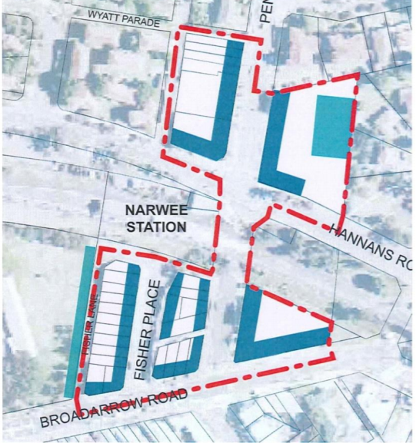
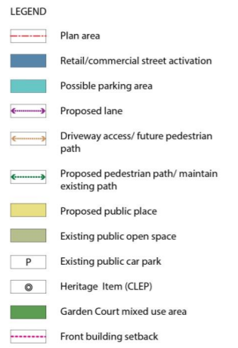
Figure 6: Narwee Local Centre structure plan

Canterbury Development Contributions Plan 2013 (Contributions Plan 2013)
The Canterbury Development Contributions Plan 2013 applies to the site and if the application was approved would attract a s.7.11 contribution.

Planning agreements [section 4.15(1)(a)(iiia)]
There are no planning agreements of draft planning agreements that are relevant to the subject proposal pursuant to Section 7.4 of the Environmental Planning and Assessment Act 1979.

The regulations [section 4.15(1)(a)(iv)]
The proposed development is not inconsistent with the relevant provisions of the Environmental Planning and Assessment Regulation, 2000.

The likely impacts of the development [section 4.15(1)(b)]
Having regard to the development failing to adequately demonstrate the sites ability to receive natural ventilation, satisfy the requirements of SEPP 55 and provide safe pedestrian links, the proposal will result in unacceptable impacts on the subject site and on the locality. The proposal is therefore not supported.

Referrals

External Referrals | Comments Received
WaterNSW (pursuant to  Section 91A of the Environmental Planning and Assessment Act 1979) | No objections subject to conditions
Sydney Trains | No objections subject to conditions
Ausgrid | No objections subject to conditions
Internal Referrals | Comments Received
Asset Planning - Stormwater | No objections subject to conditions
Traffic | Traffic matters not resolved and cannot support the application
Resource Recovery (Waste) | No objections subject to conditions
Development Engineer | No objections subject to conditions
Environmental Health Officer | SEPP 55 matters not resolved and cannot support the application
Building Surveyor | No objections raised, subject to conditions

Suitability of the site [section 4.15(1)(c)]

The proposed development is permitted with consent on the subject site and represents a built form that is compatible with the existing and future character of the locality. The application has been assessed under Section 4.15 of the Act, and as demonstrated throughout the body of this report, the proposal generally complies with the relevant development controls. The proposed variations to the relevant CLEP 2012 regarding building height have been assessed on merit and is acceptable for the reasons outlined within the body of the report.

However, insufficient information in relation to contamination, ventilation, apartment layout and size and traffic and parking results in a development that is therefore not suitable for the site and the application cannot be supported.

Submissions [section 4.15(1)(d)]
The application was advertised for a period of 28 days from 16 June 2021 to 13 July 2021 as per Council’s Community Participation Plan, including newspaper advertising and nearby residents were also notified and invited to provide comment. No submissions were received.

The public interest [section 4.15(1)(e)]
The public interest is served through the consistent and measured application of the relevant plans, policies and standards. Council generally considers that the proposal meets the relevant development standards and planning controls and variations to the controls/standards are justified. However, insufficient information in relation to contamination, ventilation, apartment layout and size and traffic and parking results in a development application which cannot be supported.

CONCLUSION
The development application has been assessed pursuant to the provisions of Section 4.15 of the Environmental Planning and Assessment Act 1979 and all relevant development control plans, codes and policies.

The design of the proposed development is compatible with the future and desired local character of the area and represents a quality development that will positively contribute to the streetscape and the local built environment. However, as a result of insufficient information in relation to contamination, ventilation, apartment layout and size, waste and traffic and parking, Council does not support the application.

RECOMMENDATION
It is recommended that the application be refused, for the following reasons:

THAT pursuant to Section 4.16(1)(b) of the Environmental Planning and Assessment Act, 1979, the Sydney South Planning Panel, for the reasons set out below refuse Development Application No. DA-503/2018/1.

- The proposed development, pursuant to the provisions of Section 4.15(1)(a)(i) of the Environmental Planning and Assessment Act 1979, is not consistent with Clause 28(2)(c) of State Environmental Planning Policy No. 65 – Design Quality of Residential Apartment Development (2002 EPI 530) with respect to:
  - Part 4B Natural Ventilation in that the proposed development conflicts with achieving suitable natural ventilation and maintaining acoustic privacy.
  - Part 4D Apartment Size and Layout in that apartments L01-06 and L02-06 are studio apartments but have a floor area which is larger than a 1 bedroom unit apartment and do not have a minimum cross through width of 2.5m resulting in snorkel apartments.

- The proposed development, pursuant to the provisions of Section 4.15(1)(a)(i) of the Environmental Planning and Assessment Act 1979, is not consistent with State Environmental Planning Policy - Remediation of Land (SEPP 55).

- Pursuant to the provisions of Section 4.15(1)(a)(i) of the Environmental Planning and Assessment Act 1979, and having regard to the reasons of this notice, it is considered that the proposed development does not satisfy the objectives contained in Clause 1.2 of the Canterbury Local Environmental Plan 2012, in particular Objective 2(c) ‘to ensure that development is of a design and type that supports the amenity and character of an area and enhances the quality of life of the community’.

- Pursuant to the provisions of Section 4.15(1)(a)(i) of the Environmental Planning and Assessment Act 1979, it is considered that the proposed development does not satisfy:
  - Clause 6.2
  - Clause 6.6 – Essential services of the Canterbury Local Environmental Plan 2012 relating to suitable vehicular access.

- The proposed development is unsatisfactory, pursuant to the provisions of Section 4.15(1)(a)(iii) of the Environmental Planning and Assessment Act 1979, as it does not comply with the provisions of the Canterbury Development Control Plan 2012 including:

  - Objective O4 of Part B1.1 – General Objectives: Transport and Parking, which aims to ensure servicing by larger vehicles occurs off-street in such a way that it reduces impacts on the pedestrian environment
  - Objective O5 of Part B1.1 – General Objectives: Transport and Parking, which seeks to ensure vehicle facilities are complaint, functional and safe.
  - Building Depth?

- The proposed development, pursuant to the provisions of Section 4.15(1)(b) of the Environmental Planning and Assessment Act 1979, is unsatisfactory given the inadequate proposed means of access to and from the development site and the area available for the loading and unloading of goods and manoeuvring of vehicles, and pedestrian safety.

- Having regard to the previous reasons noted above, pursuant to the provisions of Section 4.15(1)(e) of the Environmental Planning and Assessment Act 1979, approval of the development application is not in the public interest.

